SOFTWARE IMPLEMENTATION SPECIFICATION
Sentry Turnstile
Monitoring System
Codex Implementation Specification
Document field | Value
Purpose | Implementation-ready prompt and acceptance specification
Target repository | https://github.com/eosalalima/BlazorSentryWebApp
Reference repository | https://github.com/eosalalima/sentry
Target platform | .NET 10 Blazor Web App, Interactive Server
Production host | Microsoft IIS on Windows
Status | Draft for implementation and technical validation

Implementation directive. Reimplement the application as one cohesive Blazor project in the target repository. Preserve the .git directory and unrelated files. Inspect and summarize the intended file changes before replacing application files. Do not commit or push unless explicitly instructed.

How Codex must use this specification
Treat statements using “must” as mandatory requirements.
Do not invent database fields, device rules, or SMS recipient sources. Validate them against the actual schema or obtain the missing information before implementation.
Record every assumption in the final implementation report.
Do not consider compilation alone sufficient; complete the verification and Definition of Done in Sections 13 and 14.

1. Project Overview
The Sentry Turnstile Monitoring System is a server-hosted application for monitoring personnel entry and exit events generated by turnstile devices. It polls SQL Server for newly created access-control logs, displays the current event prominently, retains recent events temporarily, retrieves personnel photographs from a protected server folder, and optionally sends SMS notifications.

1.1 Business purpose
Provide near-real-time visibility of personnel who enter or exit through monitored turnstiles.
Make recent access events easy to verify visually at the monitoring station.
Reduce repeated, skipped, and out-of-order display events through deterministic polling and queue processing.
Send configurable entry and exit notifications without interrupting monitoring.

1.2 Target users and environment
Item | Requirement
Primary users | Authorized monitoring personnel and system administrators
Server | Windows server or workstation capable of hosting IIS
Database | Microsoft SQL Server
Client | Modern desktop browser; responsive support for smaller displays
Peripheral | Server-connected GSM/SMS modem, such as SIM800C

2. Implementation Objective
Build a production-oriented replacement for the existing application in the target repository while using the reference repository only as implementation guidance.

2.1 Repository handling
Inspect the target repository before editing and identify the current projects, configuration, assets, and uncommitted changes.
Preserve .git, repository history, documentation, deployment files, and files unrelated to the application.
Consolidate the application into one Blazor Web App project unless an existing solution-level file is required for tooling.
Do not delete, reset, commit, push, or rewrite Git history unless explicitly authorized.
If the reference repository conflicts with this specification, this specification takes precedence.

3. Technology Stack
Component | Required choice
Application framework | .NET 10 Blazor Web App
Render mode | Interactive Server
Data access | Entity Framework Core or Dapper; use parameterized SQL
Database | Microsoft SQL Server
Hosting | IIS on Windows with the .NET Hosting Bundle
Background processing | Hosted services with cancellation-token support
SMS integration | Server-side serial-port service using modem AT commands
Logging | Microsoft.Extensions.Logging with structured operational events
Testing | Unit and integration tests appropriate to the selected data-access approach

Architecture rationale. Interactive Server is required because SQL Server access, physical photo files, and the serial-port modem must be accessed on the server rather than directly from the browser.

4. System Architecture
Source / component | Processing responsibility | Consumer / result
SQL Server DeviceLogs | Polling service detects and orders new records | FIFO event queue
FIFO event queue | Display coordinator processes one active event at a time | Spotlight panel, then recent feed
Photo directory | Secure server endpoint validates PhotoId and streams a JPG | Spotlight and recent feed
Processed access event | Asynchronous SMS service formats and transmits a message | Personnel mobile number and SMS audit log
Configuration store | Validated server-side settings service supplies runtime values | Monitoring, photo, device, and SMS services

4.1 Service boundaries
Monitoring service: lifecycle, polling, checkpoint recovery, database reconnect, and cancellation.
Event coordinator: deduplication, FIFO ordering, Spotlight timing, and recent-feed retention.
Photo service: safe filename construction, existence checks, placeholder handling, and streaming.
SMS service: recipient resolution, template rendering, asynchronous send, retry, timeout, and audit.
Configuration service: validation, persistence, secret masking, and controlled runtime refresh.

5. Database Specification

5.1 Development connection
Current development value: "Server=EOS-NITRO\SQLSERVER2023;Database=Access Control;Integrated Security=True;TrustServerCertificate=True;". This value must not be hard-coded into application source. Production configuration must be supplied through IIS configuration, an environment variable, or another protected server-side secret mechanism.

5.2 Required schema confirmation
Before implementing the final query, inspect or obtain the actual definitions of DeviceLogs and its related device/personnel tables. Map the following logical fields to confirmed database columns:
Logical field | Purpose | Required status
UniqueLogId | Stable deduplication and tie-break ordering | Must be confirmed
LogTimestamp | Event order and startup lookback | Must be confirmed
PhotoId | JPG filename source | Provided; data type must be confirmed
AccessNumber / PersonnelId | Personnel identity and secondary correlation | Must be confirmed
PersonnelName | Display and SMS {Name} | Must be confirmed
DeviceId / DeviceCodeName | Filtering and display/SMS device token | Must be confirmed
Direction / EventType | Deterministic IN versus OUT mapping | Must be confirmed
MobileNumber | SMS recipient | Must be confirmed

Blocking rule. Do not guess column names, relationships, or the IN/OUT rule. If schema inspection is unavailable, stop database-query implementation and report the exact information still needed.

5.3 Query requirements
Use parameterized queries and least-privileged, read-only database access for Live Mode.
Read no more than MaxRowsPerPoll per query and order results by LogTimestamp ascending, then UniqueLogId ascending.
Apply the configured device filter in the database query where practical.
Handle transient connection failures with bounded retry and visible status without crashing the UI.

6. Functional Requirements

6.1 Monitoring controls
The header must provide a Play/Stop toggle beside the Settings cog.
Play starts monitoring and changes the icon/status to Stop/Active.
Stop cancels polling cleanly, preserves the last safe checkpoint, and changes the status to Halted.
Repeated clicks must not create multiple monitoring workers.

6.2 Event display lifecycle
Each newly detected event enters a FIFO queue.
Only one event is active in the right-side Spotlight panel at a time.
The Spotlight shows the event for HighlightDisplayDuration.
After the duration, the event moves to the left-side recent activity feed.
The next queued event enters the Spotlight immediately.
A feed item disappears after FeedRetentionDuration.
Events must not be repeated, skipped, or reordered.

6.3 Photo retrieval
Construct the filename as PhotoId + “.jpg” using the confirmed PhotoId value.
Use the configurable default directory F:\Projects\Dr. Gloria D Lacson School\Photos\Photos.
Expose photographs through a server-side endpoint or service; never expose the physical directory to the browser.
Normalize the identifier with Path.GetFileName() or equivalent, reject traversal and unexpected extensions, and allow JPG retrieval only.
If the photo is missing, invalid, or unreadable, display wwwroot/img/avatar-placeholder.svg.
Grant the IIS application-pool identity read-only access to the photo directory.

6.4 Device filtering
Populate the device dropdown from the confirmed device table or reference data source.
Support “All Devices” and a single-device selection unless the schema or business rule requires multiple selection.
Use a stable device key internally and a human-readable name for display.
Do not infer IN/OUT solely from a device name unless that mapping is explicitly confirmed.

6.5 Operating modes
Mode | Required behavior
Live Mode | Poll confirmed production access records from SQL Server. Do not write to DeviceLogs.
Demo Mode | Generate representative access events in memory and pass them through the same queue, photo, display, and optional SMS pipeline. Do not write to DeviceLogs or any production table.

7. Event Processing Rules

7.1 Startup checkpoint
When monitoring starts, establish a checkpoint from LogTimestamp and UniqueLogId.
Process only records within LookbackSecondsOnStart; do not replay older history.
If LookbackSecondsOnStart is zero, start after the newest existing record.
Persist or reconstruct the checkpoint safely enough to prevent replay after a transient reconnect.

7.2 Polling and deduplication algorithm
Query records later than the checkpoint using timestamp plus unique-ID tie-breaking.
Sort ascending by timestamp and ID before enqueueing.
Deduplicate primarily by UniqueLogId. If no stable ID exists, obtain an approved composite key; do not silently substitute one.
Advance the durable checkpoint only after records have been accepted into the processing pipeline.
Bound the in-memory processed-ID cache and queue to prevent uncontrolled growth.
Use CancellationToken throughout polling and timing operations.

7.3 Concurrency and recovery
One monitoring worker and one display coordinator may run per application instance.
Events arriving while the Spotlight is occupied wait in FIFO order.
A slow or failed SMS send must not block the queue, Spotlight timing, polling, or UI updates.
A database disconnection must set status to Disconnected/Reconnecting and retry with bounded backoff.

8. User Interface Specification

8.1 Monitoring screen
Area | Required content and behavior
Header | School identity, monitored-device label, system status, Play/Stop toggle, and Settings cog
Left panel | Recent IN and OUT/BREAK OUT items as compact photo thumbnails with personnel and event details
Right panel | Current Spotlight event with a large personnel photo, name, direction, device, and event timestamp
Status states | Halted, Active, Demo Mode, Database Disconnected, Reconnecting, No Records, SMS Unavailable, Invalid Photo Path

8.2 Settings screen
Open settings from the cog icon beside the Play/Stop control. Protect this screen for authorized administrators when authentication is available. Mask the database connection string and never send its unmasked value to browser logs or client-visible markup.

8.3 Responsive behavior
On desktop, show the recent feed on the left and Spotlight on the right.
On narrow screens, stack Spotlight before the recent feed so the current event remains primary.
Keep controls keyboard-accessible and provide text labels or tooltips for icons.
Use sufficient color contrast and meaningful non-color status labels.

9. Configuration Matrix
Setting | Unit / type | Default | Validation and behavior
Database connection string | Secret text | Development value in 5.1 | Required in Live Mode; masked; server-side only
Operating mode | Live / Demo | Live | Show persistent Demo Mode indicator
Device to monitor | Device key | All Devices | Must exist in confirmed device source
SMS COM port | Port name | COM4 | Must exist server-side; accept COMn format
Photos path | Directory | F:\Projects\Dr. Gloria D Lacson School\Photos\Photos | Must exist and be readable
PollingInterval | Milliseconds | 500 | 250–60,000
HighlightDisplayDuration | Milliseconds | 5,000 | 1,000–60,000
FeedRetentionDuration | Milliseconds | 10,000 | 1,000–300,000
LookbackSecondsOnStart | Seconds | 3 | 0–3,600
MaxRowsPerPoll | Records | 20 | 1–500
SMS timeout | Seconds | 30 | 5–120
SMS retry count | Attempts | 2 | 0–5

Non-sensitive settings may be stored in appsettings.json only when the deployed file is writable and protected, or in a dedicated external configuration store. Document whether each setting is applied immediately or requires monitoring/application restart.

10. SMS Integration

10.1 Required modem information
Confirm the actual modem and serial configuration before production use. The implementation must support configuration for COM port, baud rate, parity, data bits, stop bits, command timeout, retry count, and test recipient. Recommended initial SIM800C defaults may be proposed but must not be treated as confirmed hardware settings.

10.2 Sending behavior
Resolve the recipient from the confirmed MobileNumber field or relationship.
Queue SMS sends asynchronously after an event is accepted; never block monitoring or the UI.
Use an explicit AT-command state machine, including modem readiness, text mode, recipient command, message body, end-of-message control character, and final response parsing.
Record success, failure, retry count, response code, event ID, and timestamp without logging sensitive message content unnecessarily.
Prevent duplicate messages using the access event ID plus notification type.
A failed SMS send must surface a warning and remain retryable without replaying the display event.

10.3 Message templates
Event | Default template
Entry | ENTRY RECORDED: {Name} successfully entered through the {DeviceCodeName} on {DateTime} – Dr. Gloria D. Lacson Foundation Colleges
Exit | EXIT RECORDED: {Name} successfully exited through the {DeviceCodeName} on {DateTime} – Dr. Gloria D. Lacson Foundation Colleges

Supported tokens must be explicitly documented and validated. Unknown tokens must produce a configuration validation error rather than being sent literally.

11. Security and Operational Requirements
Use parameterized SQL and a least-privileged database identity.
Protect configuration and administrator-only settings; do not expose secrets in rendered HTML, logs, source control, or screenshots.
Validate and canonicalize all physical file paths and photo identifiers.
Use anti-forgery and standard Blazor/ASP.NET Core protections for configuration changes.
Log monitoring lifecycle, database state, configuration changes, photo failures, and SMS outcomes with timestamps and correlation IDs.
Do not log full connection strings, credentials, or unnecessary personal information.
Show recoverable errors in the UI without terminating the monitoring application.

11.1 Required status messages
Condition | User-visible status
Monitoring stopped | Halted
Monitoring running | Active
Demo generator running | Demo Mode Active
Database unavailable | Database Disconnected / Reconnecting
No new records | Waiting for turnstile logs
SMS modem unavailable | SMS Unavailable; monitoring continues
Photo path invalid | Photo Path Invalid; placeholders are being used
Settings saved | Configuration Saved

12. Deployment Requirements
Install and verify the IIS Web Server role and the .NET 10 Hosting Bundle.
Publish the Blazor Web App in Release mode for the target Windows architecture.
Use an IIS application pool with No Managed Code and an identity authorized for required resources.
Grant the application-pool identity read access to the photo directory and only the minimum database permissions.
Confirm that the server process can access the selected COM port and that no competing process has locked it.
Provide environment-specific configuration without committing production secrets.
Configure IIS bindings, application path, logging, restart behavior, and health verification.
Document backup and rollback steps before replacing a deployed version.

13. Acceptance Criteria
ID / feature | Given / When / Then acceptance criterion
AC-01 Monitoring lifecycle | Given monitoring is halted, when Play is selected, then exactly one polling worker starts, the status becomes Active, and the control changes to Stop.
AC-02 Stop behavior | Given monitoring is active, when Stop is selected, then polling ends cleanly, no new poll begins, and the status becomes Halted.
AC-03 FIFO order | Given three new records are returned in one poll, when processed, then they appear in the Spotlight in timestamp-and-ID order and move to the recent feed in the same order.
AC-04 Deduplication | Given the same UniqueLogId is returned more than once, when polls are processed, then the event is displayed and notified no more than once.
AC-05 Startup lookback | Given older and recent records exist, when monitoring starts, then only records within LookbackSecondsOnStart are eligible for processing.
AC-06 Spotlight timing | Given an event becomes active, when HighlightDisplayDuration elapses, then it leaves the Spotlight, moves to the feed, and the next queued event becomes active.
AC-07 Feed retention | Given an event is in the recent feed, when FeedRetentionDuration elapses, then the event is removed without affecting newer items.
AC-08 Photo success | Given a valid PhotoId and readable JPG exist, when the event is displayed, then the associated photograph appears without exposing the physical path.
AC-09 Photo fallback | Given the photo is missing or invalid, when the event is displayed, then avatar-placeholder.svg appears and monitoring continues.
AC-10 Device filter | Given one device is selected, when other-device records are created, then only records for the selected device are processed.
AC-11 Demo isolation | Given Demo Mode is active, when sample events are generated, then the complete UI lifecycle runs without inserting records into DeviceLogs or another production table.
AC-12 SMS non-blocking | Given the modem is unavailable, when an event is processed, then the display lifecycle completes, a warning is shown, and the failure is logged.
AC-13 SMS template | Given a valid entry event, when SMS is sent, then {Name}, {DeviceCodeName}, and {DateTime} are replaced with the correct values.
AC-14 Database recovery | Given SQL Server becomes temporarily unavailable, when connectivity returns, then monitoring resumes from the safe checkpoint without replaying processed events.
AC-15 Secret protection | Given an administrator opens settings, when the connection string is displayed or saved, then its sensitive value is masked and is absent from client logs and rendered page source.

14. Definition of Done
The project builds in Release configuration with no errors.
The application starts and the primary monitoring and settings pages load successfully.
Automated tests pass for checkpointing, ordering, deduplication, timing, template rendering, and validation.
Demo Mode is exercised end-to-end and verified not to write to production access-control tables.
Live-mode database mapping is documented against the confirmed schema.
FIFO, multiple simultaneous events, restart recovery, and duplicate prevention are verified.
Photo success, missing-photo fallback, invalid paths, and path-traversal rejection are verified.
SMS success, timeout, modem unavailability, retry, and duplicate prevention are verified.
Settings validation and secret masking are verified.
IIS deployment instructions, prerequisites, permissions, configuration, health check, rollback, and known limitations are documented.
The final report lists implemented requirements, assumptions, tests executed with results, remaining limitations, and files changed.

15. Required Implementation Report
At completion, Codex must provide a concise report containing:
Summary of the implemented architecture and user-facing behavior.
Exact files added, modified, or removed and the reason for each material change.
Confirmed database field mapping, device source, IN/OUT logic, and mobile-number source.
Configuration defaults and any environment-specific setup still required.
Commands and tests executed, with pass/fail results.
Assumptions, known limitations, deferred items, and recommended next steps.
IIS deployment and rollback instructions.

Appendix A — Information Required Before Final Live Integration
Required input | Why it is needed
CREATE TABLE definitions or schema export for DeviceLogs and related tables | Prevents invented column names and relationships
Anonymized sample rows | Validates data shapes, null behavior, timestamps, and event ordering
Unique log identifier | Required for deterministic deduplication
Confirmed IN/OUT rule | Required for display grouping and message selection
Device table and display/key columns | Required for the device dropdown and filtering
Personnel/mobile-number source | Required for names and SMS recipients
Modem model and serial parameters | Required for reliable AT-command integration
Authentication/administrator policy | Required to secure settings

Appendix B — Source Interface References
The following screenshots are retained as visual references from the original prompt. They communicate the intended layout but do not override the behavioral and security requirements in this specification.
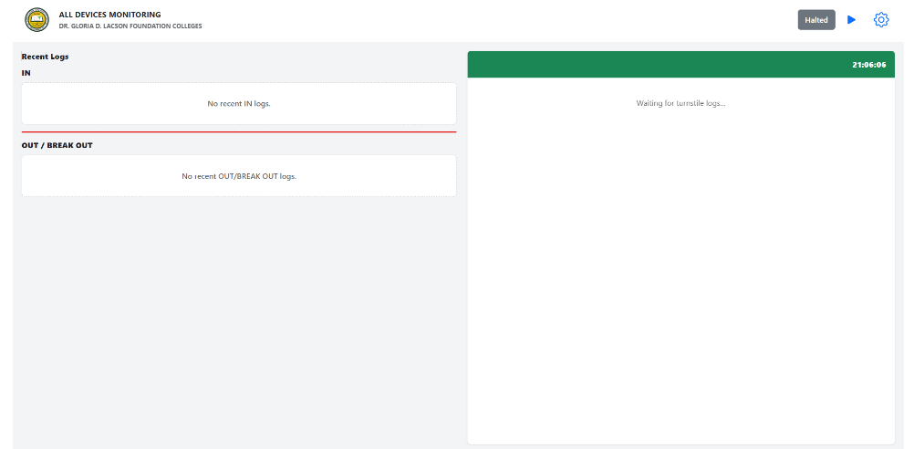
Figure B-1. Monitoring screen reference
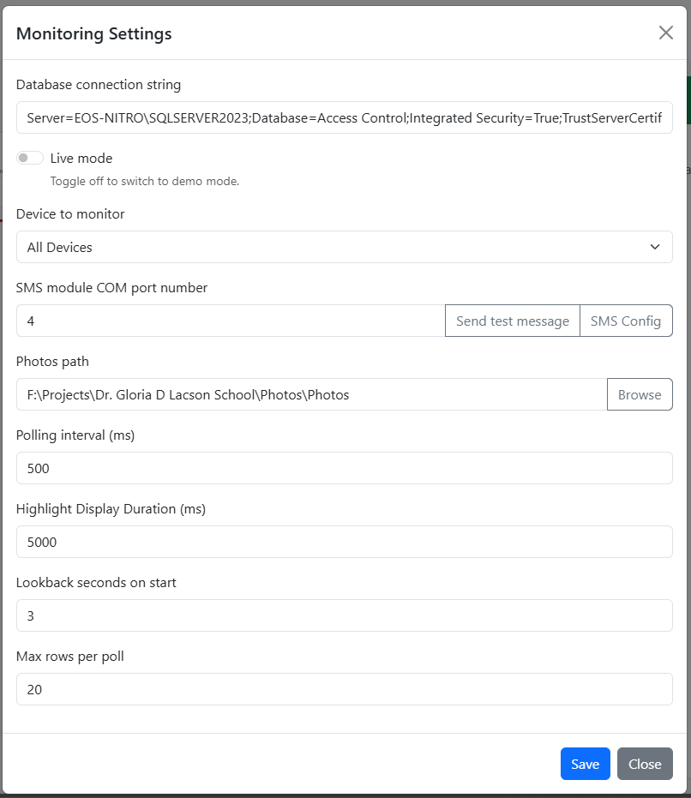
Figure B-2. Monitoring settings reference

